I’m Multi class neural classification with Azure Machine learning studio to classify handwritten notes from MNIST dataset.



1. Give a name to the project after entering into the experiment section of the studio.

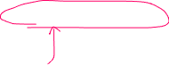

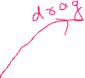

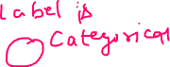

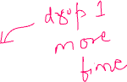

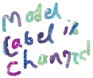

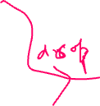

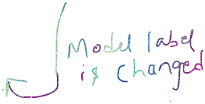

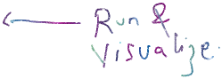

Select evaluation model -> select run

After running the model- All the icon will appear with tick mark.

1. Model evaluation.

Right click at evaluate model -> visualize



